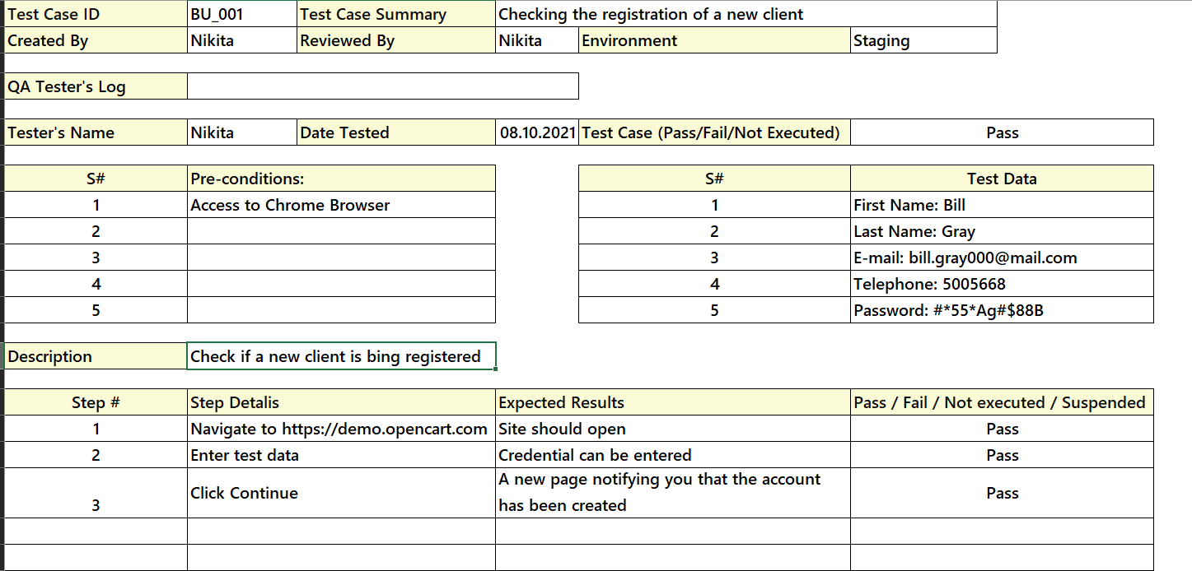

A causal design technique is applied to the first test case. That is, when entering all the data and clicking on the Continue button, an account must be created. Click on the Continue button to create an account (consequence).